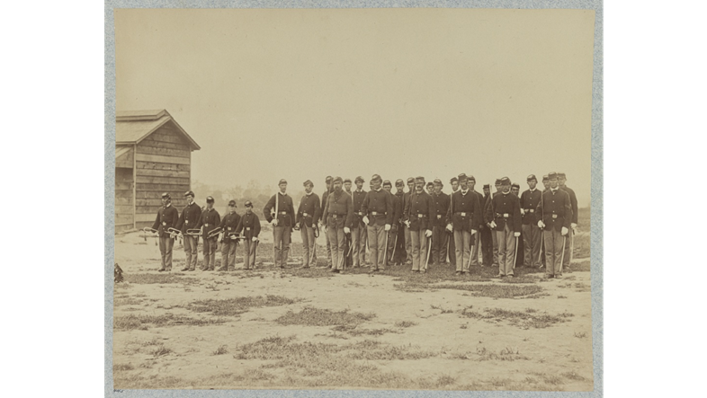
https://www.loc.gov/item/2013648497/
This photograph shows some children who were in the army during the Civil War. Look closely at the picture. What was the boys’ job?

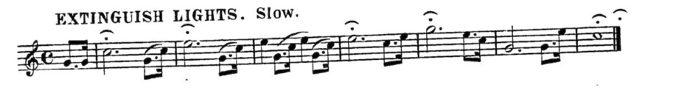
This is a bugle call. Bugle calls gave soldiers many instructions during the Civil War. This bugle call is still used in the military today. Have you ever heard a bugle call?

Read the words and look at the notes. What do you think the song will sound like? Let’s find out by using our coding skills!

- Create a new Scratch project by opening scratch.mit.edu and click Create.

- Pick a sprite to use to create your bugle call.

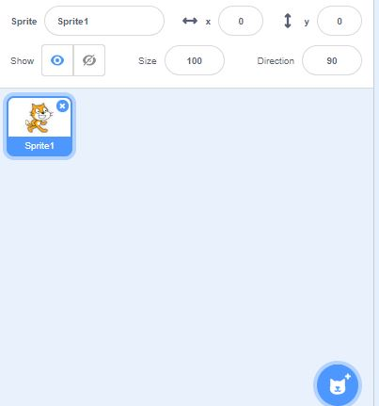

You can use Sprite 1 or hover over theto choose a new icon. If you click on , you can create your own from a file of a primary source image.
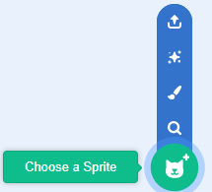

- Next click on the Events.
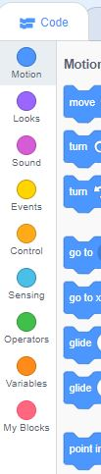

Chooseand drag it to the script area.

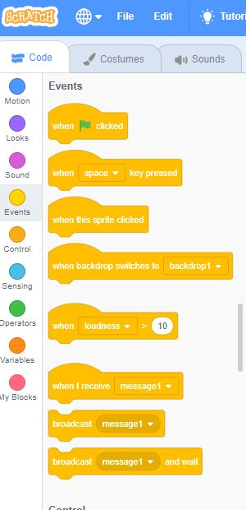

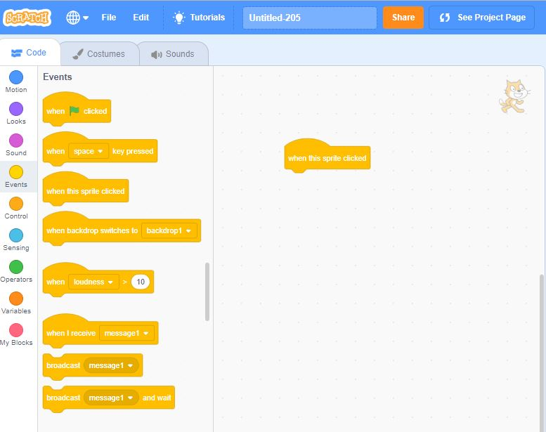

- Code the tempo of the song. What evidence do you see in the primary source to help you make your choice?

Click on Add Extensions in bottom left corner.

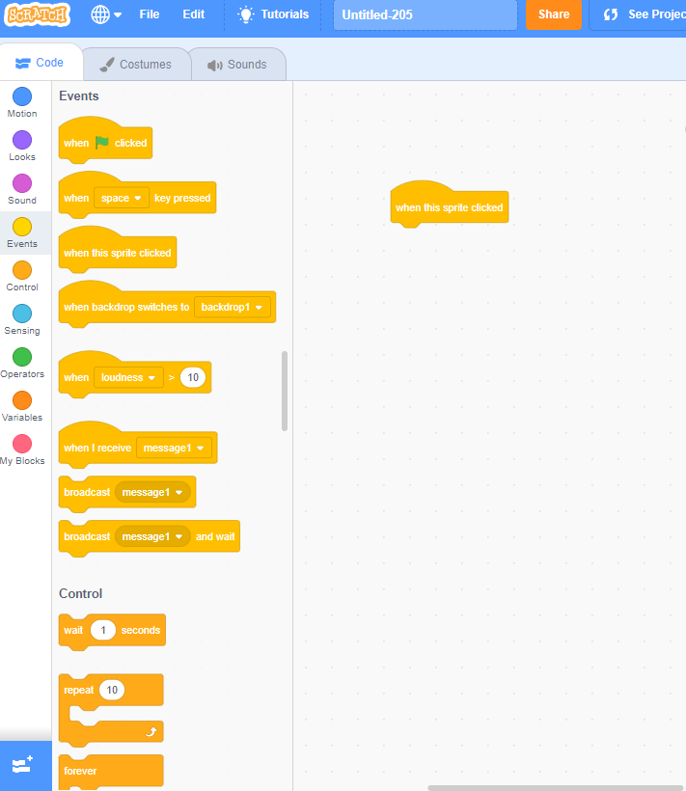

Click on the Music Extensions.
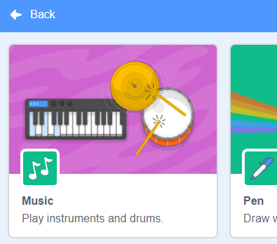

Now you should have the Music blocks at the bottom of your code choices and showing.

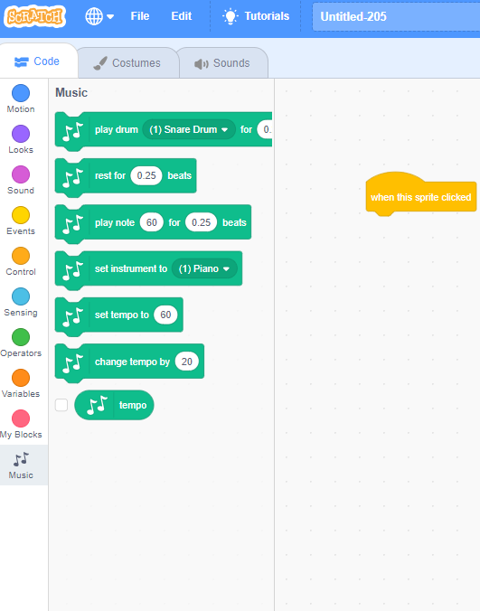
Drag the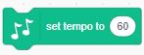 script area and connect it to the.
Set your tempo by changing the number of beats per minute in the oval.

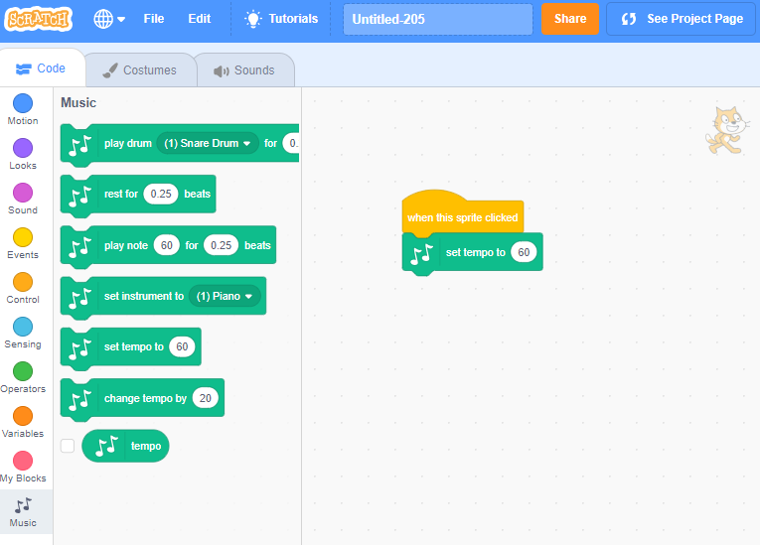

- Let’s code each note’s pitch. Use this key to select the right sound for each note.

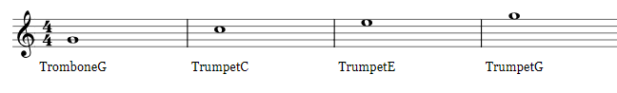
G (55) Middle C (60) E (64) G (67)

Set the instrument to (9) trombone since there is no bugle. Drag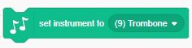over and connect it in the script area below the tempo.

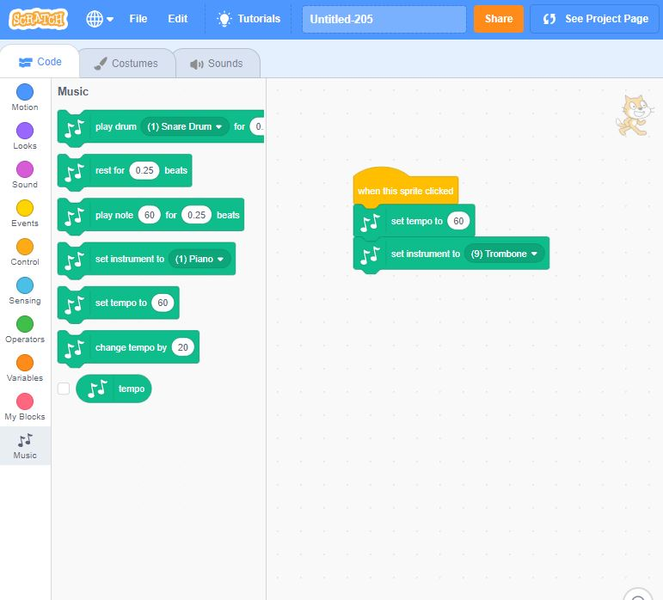

To code each note’s pitch, drag over for each note.
As you dragover, code the note by typing in the matching note number next to play note. Use the chart above and the music to know the pitch for each note. Beats will be programmed in the next step.

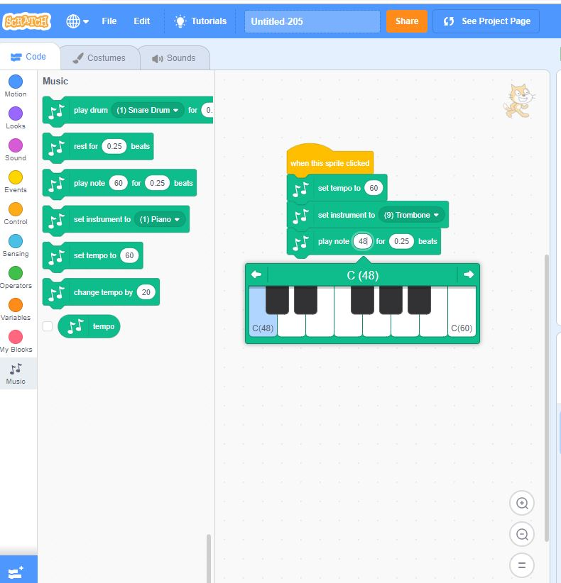

You should have 24 when you are done programming your notes’ pitches.

- Let’s code each note’s length. Do you notice that some of the notes have different shapes? The shapes tell us how long the note lasts. Use this chart to understand the notes. Look closely at the music, because sometimes the shapes appear upside-down.
What does it look like? | How long is it?
 | .25 beat
 | .75 beat
 | 1 beat
 | 3 beats
 | 4 beats

Whenever you see this symbol, you’re allowed to choose a value that is greater than the length on the chart. Be creative!

To code the note length, set the beats on each . Use the chart above and the music to know the value for each note.

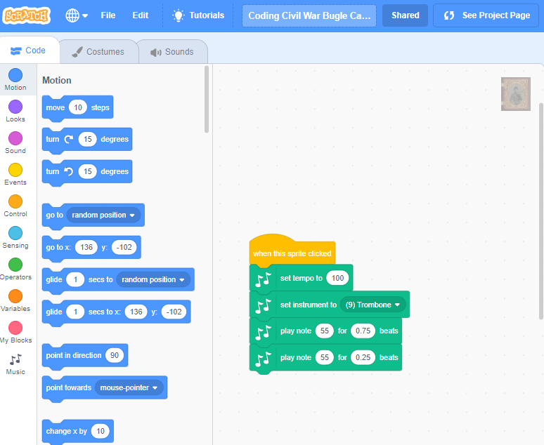

- Play your song.
- Does it sound like you predicted?
- Have you heard this song before?
- Do you think this is good music for turning off the lights? Why or why not?

If you needed to create music to wake the soldiers up in the morning, what would it sound like? Can you compose your own wake-up music by coding the tempo, pitch, and length of the notes?

Could you code the background to play an audio primary source of bugles being played?

Primary Sources used in the Coding Civil War Bugle Calls in Scratch:
https://scratch.mit.edu/projects/268767799/
Stage photo: General Grant's Cavalry escort, City Point, Va., March, 1865. Library of Congress, http://hdl.loc.gov/loc.pnp/ppmsca.34478
Sprite photo: Private James E. Staley of Band Company, 9th Indiana Infantry Regiment, and Company B, 1st Indiana Heavy Artillery Regiment. Tintype by unidentified photographer, 1861-1865. Liljenquist Collection, Library of Congress, http://hdl.loc.gov/loc.pnp/ppmsca.31124 - smallest jpeg size
Additional options:
https://www.loc.gov/item/2016652283/
https://www.loc.gov/item/2010650483/
https://www.loc.gov/item/2012648985/
https://www.loc.gov/item/2017645640/
https://www.loc.gov/item/2011647976/
https://www.loc.gov/item/2010650766/
Sheet Music: Bugle Calls, Ellis, John F. & Co., Washington, D. C, 1885, monographic. Library of Congress, https://www.loc.gov/item/sm1885.19549/
Bugle Audio: Bugle calls [played] by chief trumpeter Cassi of Roosevelt's Rough Riders, 1898. Library of Congress, https://www.loc.gov/item/00579646/
Sample script for programmed music. The last item was added on as an option for students to answer the questions.

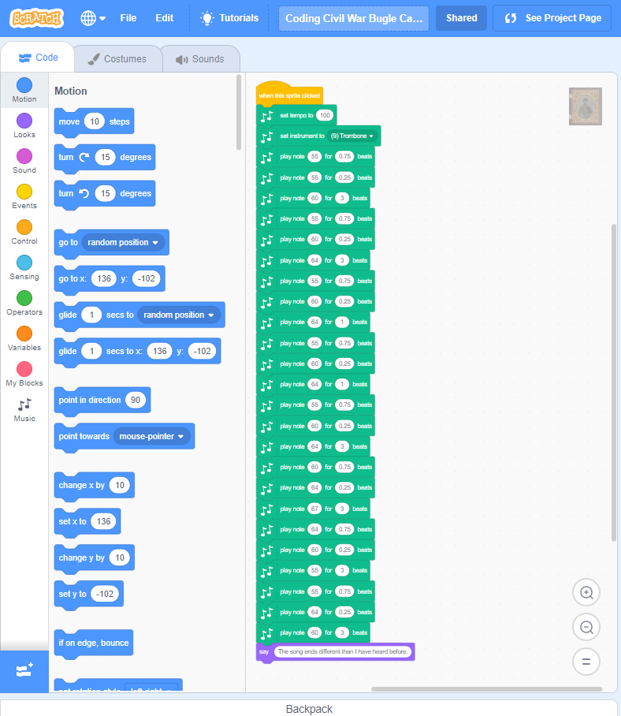
Sample script for programmed music. The last item was added on as an option for students to answer the questions.
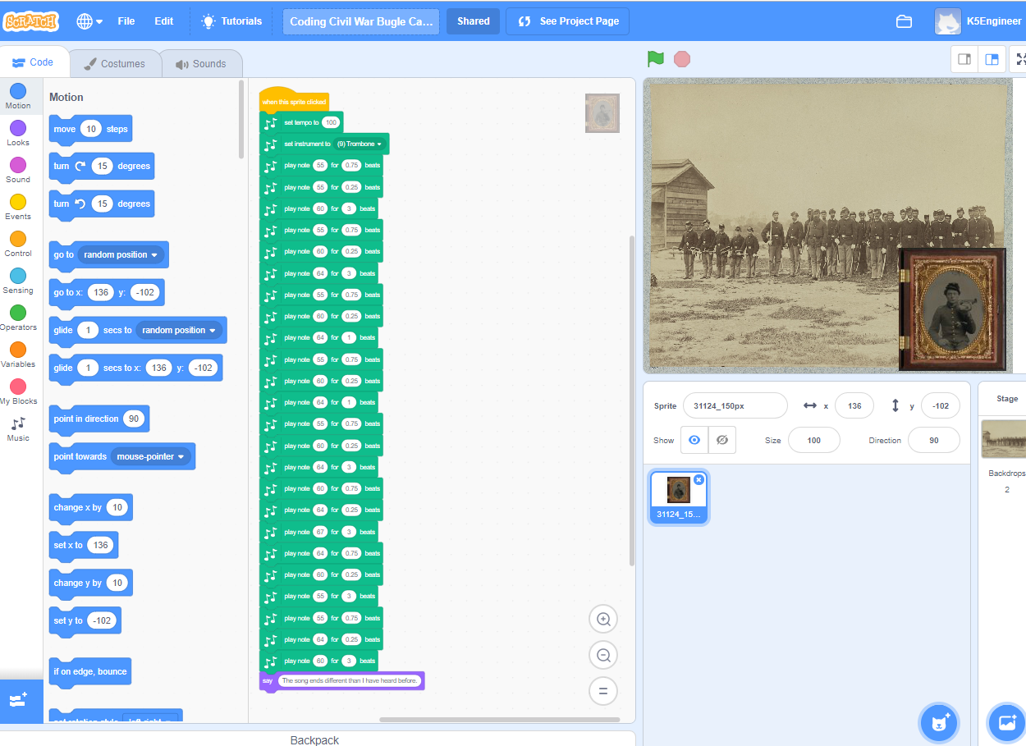

Background script for playing audio file downloaded.
